Feeling Awe May Be the Secret to Health and Happiness
OCTOBER 7, 2016 – 5:00 AM – 7 COMMENTS
1.4K

By PAULA SPENCER SCOTT @PSpencerScott
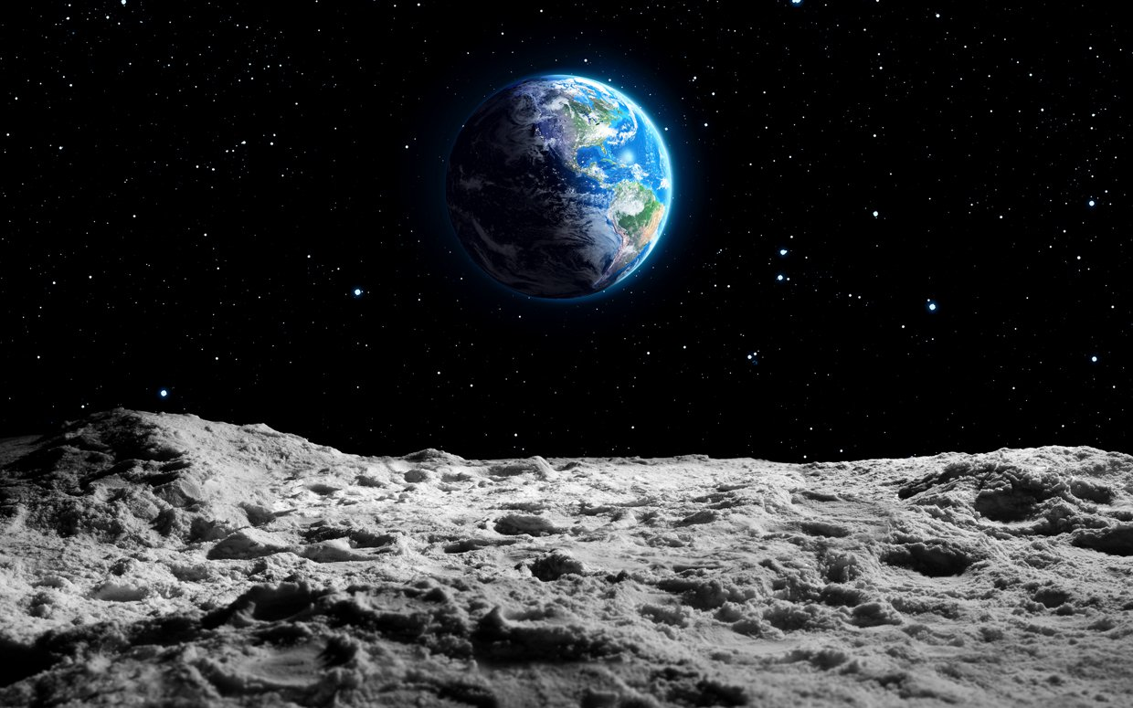(Romolo Tavani/iStock Photo)
The hike, in a narrow box canyon, wasn’t going so well. Stacy Bare and his brother were arguing, for one thing. High sandstone walls hid any view, even from the 6-foot-7 Bare. After a second Army deployment, in Iraq, he was suffering from post-traumatic stress disorder (PTSD): drinking too much, suicidal and struggling to find his way forward. What am I doing with my life? What does it mean to be at home, a veteran, anyway?
The trail led to a ladder. “We climbed up, still shouting at one another,” recalls Bare. “Then we looked up and wham! ”
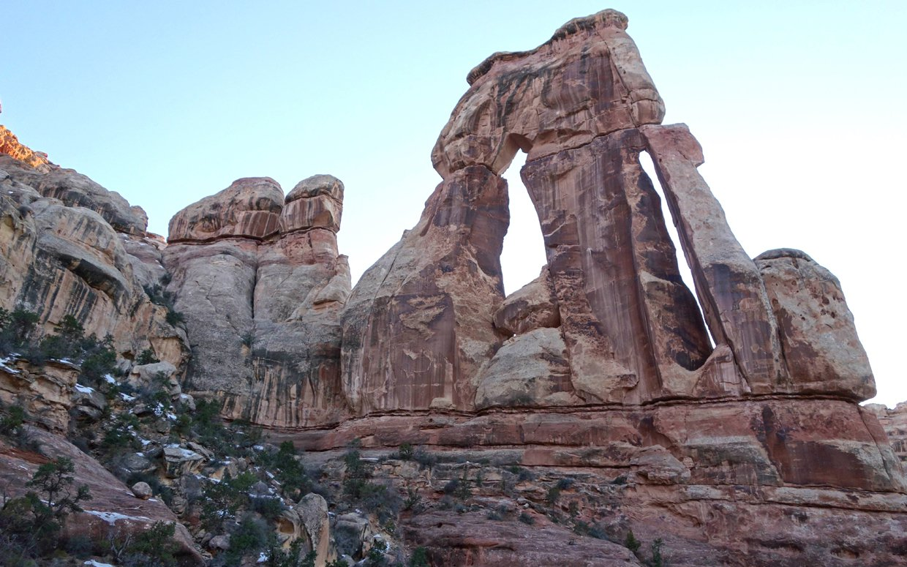Druid Arch (Courtesy Stacy Bare)
The towering slabs of Druid Arch rose up, a sunset-hued Stonehenge in the middle of Utah’s Canyonlands National Park. The men’s jaws dropped. They laughed. They hugged. What were we even arguing about? Bare recalls thinking.
They’d been awestruck—altered in an instant by an electrifying emotion that scientists have only recently begun to study. You didn’t see Awe as a character in Pixar’s hit film Inside Out. But new studies show that it’s a dramatic feeling with the power to inspire, heal, change our thinking and bring people together.

What is awe, anyway?
“Awe is the feeling of being in the presence of something vast or beyond human scale, that transcends our current understanding of things,” says psychologist Dacher Keltner, who heads the University of California, Berkeley’s Social Interaction Lab. A pioneer in the study of emotions, he helped Facebook create those new “like” button emojis and consulted on Inside Out.
In 2013, Keltner’s lab kicked off Project Awe, a three-year research project funded by the John Templeton Foundation that has spawned more research on the topic than in the previous three decades.
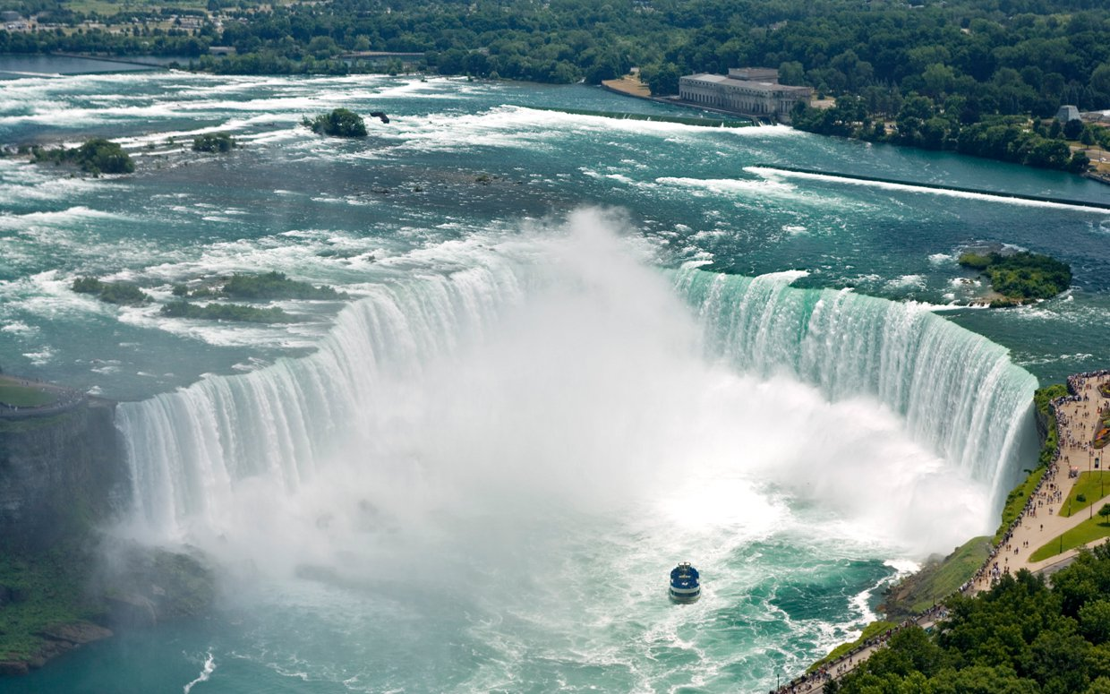Niagara Falls (Darwin Wiggett/First Light Aurora Photos)
You might recognize awe as that spine-tingling feeling you get gazing at the Milky Way. The dumbstruck wonder you feel as your newborn’s hand curls around your pinkie. Niagara Falls! Cirque du Soleil! Fireworks! The Sistine Chapel! The national anthem sung by someone who knows how!
(iStock Photo)
“People often talk about awe as seeing the Grand Canyon or meeting Nelson Mandela,” Keltner says. “But our studies show it also can be much more accessible—a friend is so generous you’re astounded, or you see a cool pattern of shadows and leaves.”
Related: 7 Ways to Find Awe in Everyday Life
For years, only the “big six” emotions (happiness, sadness, fear, anger, disgust, surprise) got much scientific attention. “Awe was thought of as the Gucci of the emotion world—cool if you have it, but a luxury item,” says Arizona State University psychologist Michelle Shiota. “But it’s now thought to be a basic part of being human that we all need.”
Here’s what these “wizards of awe” are discovering:
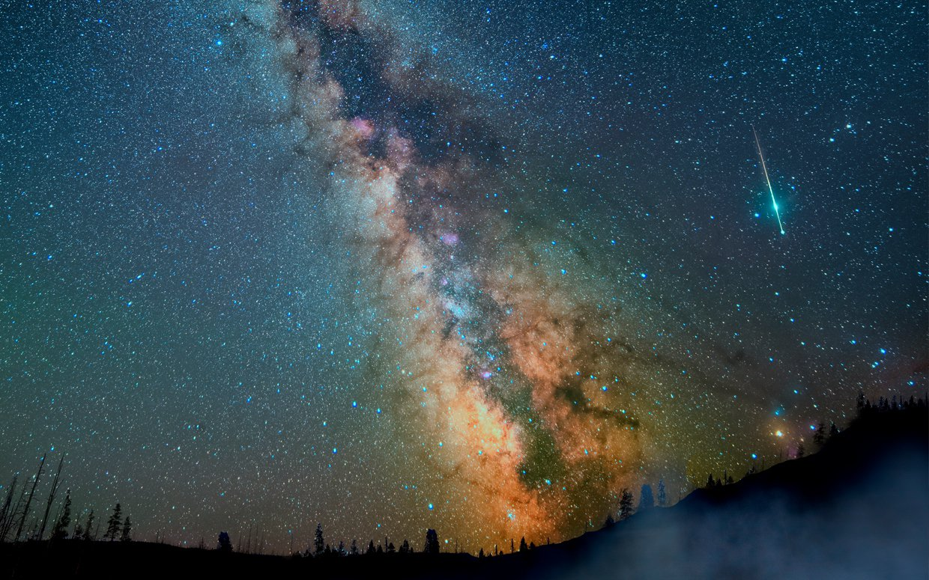(Romolo Tavani/iStock Photo)
Awe binds us together. It’s a likely reason human beings are wired to feel awe, Keltner says: to get us to act in more collaborative ways, ensuring our survival. Facing a great vista—or a starry sky or a cathedral—we realize we’re a small part of something much larger. Our thinking shifts from me to we.
Astronauts feel this in the extreme. They often report an intense, “far out” state of oneness with humanity when looking back at Earth, called the “overview effect,” says David Bryce Yaden, a researcher at the University of Pennsylvania. Our pale blue dot “looks small against the vastness of space and yet represents all that we hold meaningful,” he says. Call it a wow of astronomical proportions.
2.5
Average number of times a week people feel awe
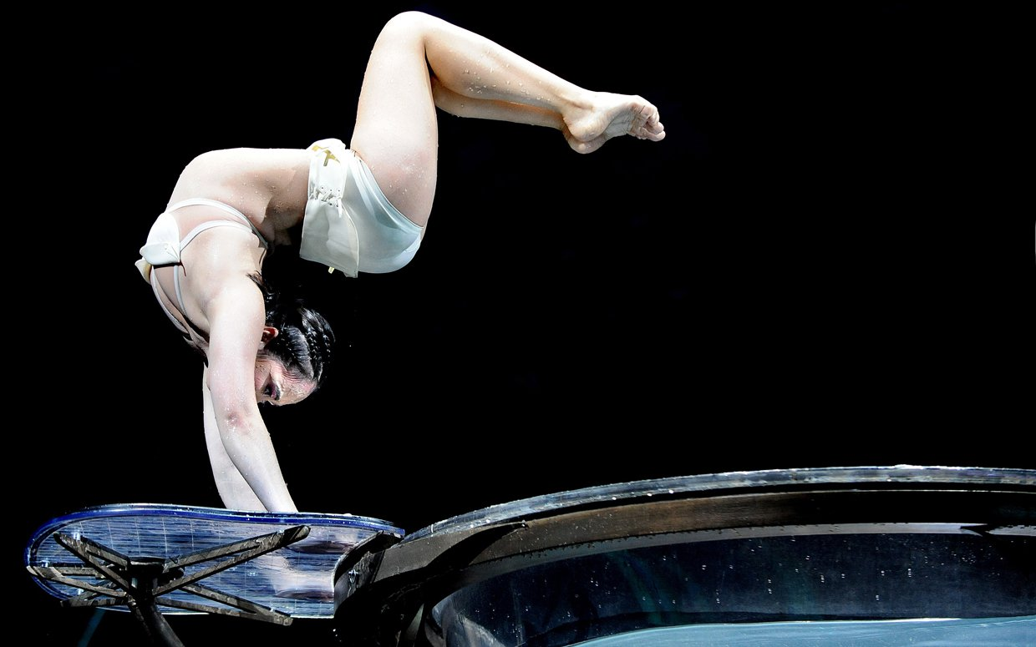(Shirlaine Forrest/Getty Images)
Awe helps us see things in new ways. Unlike, say, fear or excitement, which trip our “fight-or-flight” response, awe puts on the brakes and keeps us still and attentive, says Shiota. This “stop-and-think” phenomenon makes us more receptive to details and new information. No wonder Albert Einstein described feelings of awe as “the source of all true art and science.”
(iStock Photo)
Awe makes us nicer—and happier. “Awe causes a kind of Be Here Now that seems to dissolve the self,” says social psychologist Paul Piff of the University of California, Irvine. It makes us act more generously, ethically and fairly.
In one experiment, subjects spent a full minute looking at either an impressive stand of North America’s tallest eucalyptus trees or a plain building. Not surprisingly, the tree-gazers reported higher awe. When a tester “accidentally” dropped pens in front of the subjects, the awestruck ones helped pick up way more than the others.
75%
How much awe is inspired by the natural world
Awe alters our bodies. Awe is the positive emotion that most strongly predicts reduced levels of cytokines, a marker of inflammation that’s linked to depression, according to research from University of Toronto’s Jennifer Stellar. That suggests a possible role in health and healing, and may help explain the raft of recent studies that have linked exposure to nature with lower blood pressure, stronger immune systems and more. Researchers even wonder whether a lack of nature and other opportunities for feeling awe might add to the stresses and health damage that come from living in urban blight or poverty.
Wizards of Awe
Check out some cool projects that are trying to capture awe:
The Varieties Corpus: Penn’s new site is collecting spiritual and self-transcendent experiences, those moments of connecting with something greater than ourselves.
Shots of Awe: Jason Silva’s Discovery Digital series consists of rapid-fire micro-documentaries about futurism, innovation and all things wow.

The healing potential of awe
Though this is still pretty new science, it’s already being applied to the real world. At Newcomers High School in Long Island City, N.Y., Julie Manntakes her students on “Awe Walks” to connect with nature or art. When they write about these experiences and share them in the classroom, she says, kids who never talk in class or pay attention come to life. “It helps them feel less marginalized, with a sense that life is still good,” she says.
Kids and grown-ups alike have fewer chances these days to find such transformative moments. We’re increasingly stressed, indoors, plugged into devices and less tightly connected to neighbors and friends. Could more awe be just what the doctor ordered?
Bare thinks so. He credits backpacking and rock-climbing trips with nothing less than saving his life. “I literally climbed out of depression,” he says.
In 2010, not long after that Druid Arch hike with his brother, Bare and fellow vet Nick Watson co-founded Veterans Expeditions to get other returning soldiers (from all eras) outdoors. Like him, they reported relief from PTSD.
Fascinated, Bare sensed that there may be something therapeutic in nature beyond exercise and relaxation—something like the psychological and social shifts that awe brings. Now the director of Sierra Club Outdoors, the arm of the environmental group that organizes wilderness trips for groups, he’s partnered with UC Berkeley to form the Great Outdoors Lab to document nature’s impact on the mind, body and relationships.
Early studies have taken veterans and underserved adolescents white-water rafting. Subjects showed measured improvements in psychological well-being, social functioning and life outlook. “Veterans’ stress dropped by 30 percent. It’s a compelling pattern,” says researcher Craig Anderson.
In fact, Bare has a prediction: “In a few years, you’ll go to the doctor and, as part of treatment for trauma, you’ll get a prescription to get some hiking boots or go on a rafting trip.”
Meanwhile, he has a new source of transcendence every bit as wham! as Canyonlands’ red-gold spires: his baby daughter, Wilder.
Awesome name, right?

